Software Requirements Specification

for

Spa Salon Management System

Version 1.0 approved

Prepared by Khang HV / Duc NT

SE1410

26/10/2020

Table of Contents

Table of Contents ii

Revision History ii

1. Introduction 1

1.1 Purpose 1

1.2 Document Conventions 1

1.3 Project Scope 1

1.4 References 1

2. Overall Description 2

2.1 Product Perspective 2

2.2 User Classes and Characteristics 2

2.3 Operating Environment 3

2.4 Design and Implementation Constraints 3

2.5 Assumptions and Dependencies 3

3. System Features 4

3.1 System Feature 1 4

3.2 System Feature 2 (and so on) 4

4. Data Requirements 27

4.1 Logical Data Model 27

4.2 Data Dictionary 29

4.3 Reports 31

4.4 Data Acquisition, Integrity, Retention, and Disposal 31

5. External Interface Requirements 31

5.1 User Interfaces 31

5.2 Software Interfaces 31

5.3 Hardware Interfaces 31

5.4 Communications Interfaces 31

6. Quality Attributes 31

6.1 Usability 31

6.2 Performance 32

6.3 Security 32

6.4 Safety 32

7. Internationalization and Localization Requirements 32

8. Other Requirements 33

Appendix A: Analysis Models Error! Bookmark not defined.

Revision History

|  |  |  |  |
| --- | --- | --- | --- |
| **Name** | **Date** | **Reason For Changes** | **Version** |
|  |  |  |  |
|  |  |  |  |

# 1. Introduction

## 1.1 Purpose

## This SRS describes the functional and nonfunctional requirements for software release 1.0 of the Spa Salon Management System (SSMS). This document is intended to be used by the members of the project team who will implement and verify the correct functioning of the system. Unless otherwise noted, all requirements specified here are committed for release 1.0.

## 1.2 Document Conventions N/A

## 1.3 Project Scope

|  |  |  |  |
| --- | --- | --- | --- |
| Feature | Release 1 | Release 2 | Release 3 |
| FE-1, Order and pay for services from the spa salon’s catalog | Customers can only choose services that have in the catalog, only pay directly when customers come to the spa salons | Accept credit and debit card payments | Accept additional requirements from customers about salon services if it is possible (through note) |
| FE-2, Order and pay for products from spa salon to be delivered | Customers can only pay directly for products when customers come to the spa salons | Accept credit and debit card payments |  |
| FE-3, Create, view, modify, and delete services | Fully implemented |  |  |
| FE-4, Create, view, modify, and delete services | Fully implemented |  |  |
| FE-5, Create, view, modify, and delete services | Fully implemented |  |  |
| FE-6, System access | Internet access | Desktop App for admin | iOS and Android phone and tablet apps for staffs and customers |
| FE-7, Membership subscription for customers | Not implemented | Membership subscription for customers (no promotion) | Fully implemented and applied promotions |

## 1.4 References

1. Class Design slide – IBM

# 2. Overall Description

## 2.1 Product Perspective

### 2.1.1 Background

Nowadays, people find that beauty and relaxing services are more interesting which leads to more and more people come to spa salons to relax and to beautify themselves. As a result, many people may have to wait for a long time to enjoy the services if the spa salons have too many customers at the same time. Coming to the spa’s location to book the services schedule is an inconvenient way that is time-consuming and unworthy for customers. In the spa manager’s view, the loss of customers because of those reasons can negatively affect their revenue and reputation.

### 2.1.2 Business Opportunity

Many spa owners demand a system that could help customers to see the schedule of the services of spa salons so that they can book their service turns at the salons at a specific time and date. Such a system can help customers to save their time and effort. Moreover, the list of services of spa salons can be shown to customers in detail so that they can easily select the services that are suitable for them each time they want to book their desired services at the salon. From the salon staff's view, the systems can help them to acknowledge their schedule. Staff can acquire information on what kind of services they will do and who they will provide services for. The future ability for customers who want to book schedule at spa salons would in-app purchasing service and provide the possibility of convenience when the system is promised to cooperate with many online banking companies.

### 2.1.3 Business Objectives

BO-01: Reduce 15% spa operating cost

BO-02: The app will be used by 6% spa salons and 50,000 spa customers in the city after 3 months initial release.

BO-03: The app will be used by 18% spa salons and 110,000 spa customers in the city after 6 months initial release.

BO-04: The app will be used by 25% spa salons and 200,000 spa customers in the city after 1-year initial release.

### 2.1.4 Vision Statement

For customers who want to enjoy the spa’s services without waiting for so long before this app was deployed, the SSMS is an Internet-based and smartphone-enabled application that will help customers to book spa services, process payments, purchase spa’s products online, and read news and trending beauty articles. Unlike scheduling by phone and coming to the spa location, the customer who uses the SSMS can actively get a suitable time and staff who will do the services for the customer, which will help them to save a large amount of time and effort.

For spa managers who want to easily manage spa services, staff and spa’s beauty products and see revenue reports, using the SSMS is one of the most convenient ways to implement the former demands. Unlike the paper way, with SSMS the system is real-time based which means the information is always up-to-date and the data is transparent to the managers

### 2.1.5 Business Risks

RI-01: Too few spa salons and customers might use this system, affect the revenue and the investment of the system (Probability = 0.35; Impact = 9)

RI-02: The latency of the services provided to customers (Probability = 0.2; Impact = 4)

RI-03: The competition with other system providers (Probability = 0.3; Impact = 3)

## 2.2 User Classes and Characteristics

|  |  |
| --- | --- |
| Spa customer | A spa customer is the one who will order products, services, and get membership from the SSMS. Spa customers are expected to use the SSMS an average of 3 times per week each. An estimated 80 percent of orders will be placed from home or by mobile app, while the remaining 20 percent will be placed from the website or physical. |
| Staff | The Spa System employs about 20 Spa Staffs who will receive a schedule to do services from the SSMS, do services for the customer. Most of the Spa Staffs will need training in the use of hardware and software for the SSMS. |
| Spa Manager | The Spa Manager is a spa employee who will manage all the posts, staffs, products, and articles for the spa system. |

## 2.3 Operating Environment

OE-1: The SSMS shall operate correctly with the following web browsers: Firefox, Google Chrome, Opera, Safari.

OE-2: The SSMS shall operate on a server running the current corporate-approved versions of Ubuntu and Apache HTTP Server.

OE-3: The SSMS shall permit users to access via Android, iOS, and Windows smartphones and tablets.

## 2.4 Design and Implementation Constraints

CO-1: The system shall use the current corporate standard Microsoft SQL Server database engine.

CO-2: All HTML code shall conform to the HTML 5.0 standard.

CO-3: The programming language using in SSMS is Java.

CO-4: The framework using in SSMS is Spring Boot.

## 2.5 Assumptions and Dependencies

AS-1: System will work well when the spa’s staffs and beauty products are always available.

AS-2: The customers always arrive at the salons on time.

# 3. System Features

## 3.1 System Feature 1

FE-1: Order and pay for services from the spa salon’s catalog.

FE-2: Order and pay for products from the spa salon to be delivered.

FE-3: Create , view, modify, and delete services for admin.

FE-4: Create , view, modify, and delete products for admin.

FE-5: Create , view, modify and delete staffs for admin.

FE-6: Provide system access through corporate mobile devices for customers, staffs and desktop app for admin.

FE-7: Membership subscription for customers

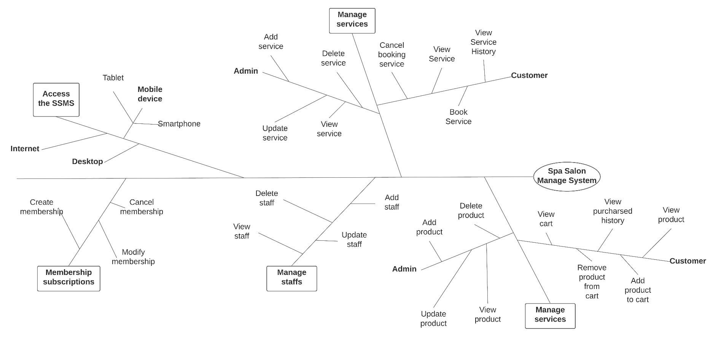

## 3.2 System Feature 2

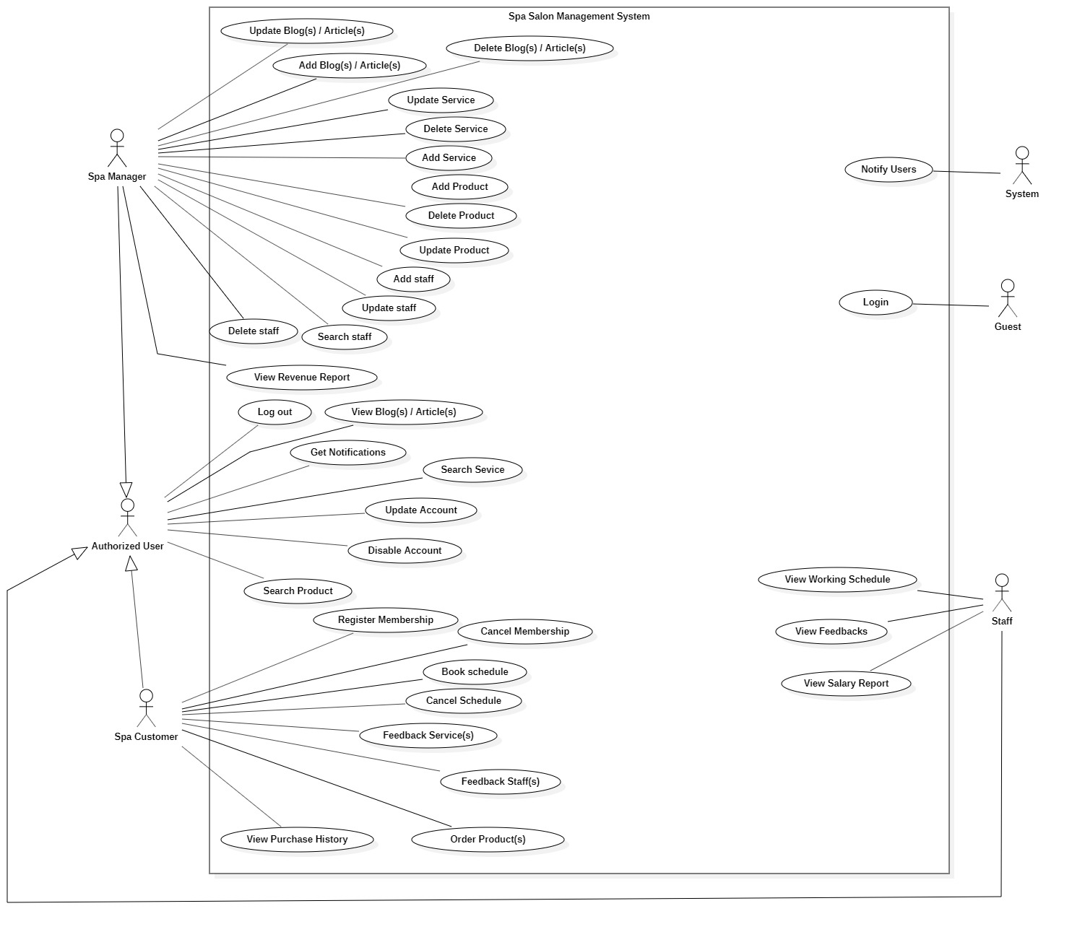

|  |  |  |  |
| --- | --- | --- | --- |
| UC ID and Name: | UC-1 Add Article Use case | | |
| Created By: | KhangHV | Date Created: | 9-10-2020 |
| Primary Actor: | Spa Manager | Secondary Actors: | Spa Salon Management System |
| Trigger: | User clicks the “Post Article” button | | |
| Description: | User can post articles into the system for spa customer to read | | |
| Preconditions: | PRE-1: User is logged into the SSMS* as a Spa Manager | | |
| Postconditions: | POST-1: The Articles posted will be stored in SSMS* with the status “active” | | |
| Normal Flow: | 1. System displays a form to post an article for manager  2. Manager inputs all fields  3. Manager clicks “Post Article” button  4. System stores the articles that contain all the parameters managers provided before  5. System shows “success” notifications | | |
| Alternative Flows: | **1.1 Manager inputs wrong format of the articles**  1. System shows the corresponding message of the incorrect fields in step 2 of normal flow  2. Return to step 1 of normal flow | | |
| Exceptions: | 1. **E1 Server crash or session time-out**   1. The system will connect in a few seconds and redirect to the login screen | | |
| Priority: | Low | | |
| Frequency of Use: | Approximately 2 -3 times a month, only when managers want to provide a promotion or share some information through articles | | |
| Business Rules: | BR-7 | | |
| Other Information: | N/A | | |
| Assumptions: | Assume that the database connection when adding has no exception | | |

|  |  |  |  |
| --- | --- | --- | --- |
| UC ID and Name: | UC-2 Update Article Use case | | |
| Created By: | KhangHV | Date Created: | 9-10-2020 |
| Primary Actor: | Spa Manager | Secondary Actors: | Spa Salon Management System |
| Trigger: | User clicks the “Edit Article” button | | |
| Description: | User can update articles of the system for spa customer to read | | |
| Preconditions: | PRE-1: User is logged into the SSMS* as a Spa Manager  PRE-2: User is in the detail page of the desired article to update | | |
| Postconditions: | POST-1: The Articles updated will be stored in SSMS* with new “last update time” and “update person” | | |
| Normal Flow: | 1. System displays a form to update article for manager  2. Manager inputs all fields  3. Manager clicks “Update Article” button  4. System updates the articles that contain all the parameters managers provided before  5. System shows “success” notifications | | |
| Alternative Flows: | **2.1 Manager inputs wrong format of the articles**  1. System shows the corresponding message of the incorrect fields in step 2 of normal flow  2. Return to step 1 of normal flow | | |
| Exceptions: | 1. **E1 Server crash or session time-out**   1. The system will connect in a few seconds and redirect to the login screen | | |
| Priority: | Low | | |
| Frequency of Use: | Rarely use, only if spa manager wants to update article because some spelling mistakes | | |
| Business Rules: | BR-7 | | |
| Other Information: | N/A | | |
| Assumptions: | Assume that the database connection when updating has no exception | | |

|  |  |  |  |
| --- | --- | --- | --- |
| UC ID and Name: | UC-3 Delete Article Use case | | |
| Created By: | KhangHV | Date Created: | 9-10-2020 |
| Primary Actor: | Spa Manager | Secondary Actors: | Spa Salon Management System |
| Trigger: | User clicks the “Delete Article” button | | |
| Description: | User can “delete” articles of the system | | |
| Preconditions: | PRE-1: User is logged into the SSMS* as a Spa Manager  PRE-2: User is on the detail page of the desired article to delete | | |
| Postconditions: | POST-1: The Articles deleted will be updated in SSMS* with new “last update time”, “update person” and status “deleted” | | |
| Normal Flow: | 1. System displays a form “Are you sure?” to confirm  2. Manager clicks “Yes”  3. System updates the status “deleted” of the desired article  4. System shows “success” notifications  5. System redirects the user to the showing list of articles page | | |
| Alternative Flows: | **3.1 Manager clicks “No” in step 2 of normal flow**  1. System redirects the user to the detail page of the desired article | | |
| Exceptions: | 1. **E1 Server crash or session time-out**   1. The system will connect in a few seconds and redirect to the login screen | | |
| Priority: | Low | | |
| Frequency of Use: | 2 – 3 times a month, only if the spa manager wants to disable some old articles | | |
| Business Rules: | BR-7 | | |
| Other Information: | N/A | | |
| Assumptions: | Assume that the database connection when deleting has no exception | | |

|  |  |  |  |
| --- | --- | --- | --- |
| UC ID and Name: | UC-4 Add Service Use case | | |
| Created By: | KhangHV | Date Created: | 9-10-2020 |
| Primary Actor: | Spa Manager | Secondary Actors: | Spa Salon Management System |
| Trigger: | User clicks the “Add Service” button | | |
| Description: | User can add services into the system for spa customer to book | | |
| Preconditions: | PRE-1: User is logged into the SSMS* as a Spa Manager | | |
| Postconditions: | POST-1: The Service posted will be stored in SSMS* with the status “available” | | |
| Normal Flow: | 1. System displays a form to add service for manager  2. Manager inputs all fields  3. Manager clicks “Add Service” button  4. System stores the service that contains all the parameters managers provided before  5. System shows “success” notifications | | |
| Alternative Flows: | **4.1 Manager inputs wrong format of the services**  1. System shows the correspond message of the incorrect fields in step 2 of normal flow  2. Return to step 1 of normal flow | | |
| Exceptions: | 1. **E1 Server crash or session time-out**   1. The system will connect in a few seconds and redirect to the login screen | | |
| Priority: | Low | | |
| Frequency of Use: | Sometimes, when manager team comes up with new services | | |
| Business Rules: | BR-6 | | |
| Other Information: | N/A | | |
| Assumptions: | Assume that the database connection when adding has no exception | | |

|  |  |  |  |
| --- | --- | --- | --- |
| UC ID and Name: | UC-5 Update Service Use case | | |
| Created By: | KhangHV | Date Created: | 9-10-2020 |
| Primary Actor: | Spa Manager | Secondary Actors: | Spa Salon Management System |
| Trigger: | User clicks “Edit Service” button | | |
| Description: | User can update services of the system for spa customer to read | | |
| Preconditions: | PRE-1: User is logged into the SSMS* as a Spa Manager  PRE-2: User is in the detail page of the desire service to update | | |
| Postconditions: | POST-1: The Services updated will be stored in SSMS* with new “last update time” and “update person” | | |
| Normal Flow: | 1. System displays a form to update service for manager  2. Manager inputs all fields  3. Manager clicks “Update Service” button  4. System updates the services that contains all the parameters managers provided before  5. System shows “success” notifications | | |
| Alternative Flows: | **5.1 Manager inputs wrong format of the service**  1. System shows the correspond message of the incorrect fields in step 2 of normal flow  2. Return to step 1 of normal flow | | |
| Exceptions: | 1. **E1 Server crash or session time-out**   1. The system will connect in a few seconds and redirect to the login screen | | |
| Priority: | Low | | |
| Frequency of Use: | Rarely use, only if spa manager wants to update services to set the price, the status, … | | |
| Business Rules: | BR-6 | | |
| Other Information: | N/A | | |
| Assumptions: | Assume that the database connection when updating has no exception | | |

|  |  |  |  |
| --- | --- | --- | --- |
| UC ID and Name: | UC-6 Delete Service Use case | | |
| Created By: | KhangHV | Date Created: | 9-10-2020 |
| Primary Actor: | Spa Manager | Secondary Actors: | Spa Salon Management System |
| Trigger: | User clicks “Delete Service” button | | |
| Description: | User can “delete” service of the system | | |
| Preconditions: | PRE-1: User is logged into the SSMS* as a Spa Manager  PRE-2: User is in the detail page of the desire service to delete | | |
| Postconditions: | POST-1: The Services deleted will be updated in SSMS* with new “last update time”, “update person” and status “deleted” | | |
| Normal Flow: | 1. System displays a form “Are you sure?” to confirm  2. Manager clicks “Yes”  3. System updates the status “deleted” of the desire service  4. System shows “success” notifications  5. System redirects user to the showing list of services page | | |
| Alternative Flows: | **6.1 Manager clicks “No” in step 2 of normal flow**  1. System redirects user to the detail page of the desire service | | |
| Exceptions: | 1. **E1 Server crash or session time-out**   1. The system will connect in a few seconds and redirect to the login screen | | |
| Priority: | Low | | |
| Frequency of Use: | Super-rarely use, only if spa manager wants to disable some old services or stops providing some services | | |
| Business Rules: | BR-6 | | |
| Other Information: | N/A | | |
| Assumptions: | Assume that the database connection when deleting has no exception | | |

|  |  |  |  |
| --- | --- | --- | --- |
| UC ID and Name: | UC-7 Add Product Use case | | |
| Created By: | KhangHV | Date Created: | 9-10-2020 |
| Primary Actor: | Spa Manager | Secondary Actors: | Spa Salon Management System |
| Trigger: | User clicks “Add Product” button | | |
| Description: | User can add products into the system for spa customer to buy | | |
| Preconditions: | PRE-1: User is logged into the SSMS* as a Spa Manager | | |
| Postconditions: | POST-1: The Product posted will be stored in SSMS* with the status “available” | | |
| Normal Flow: | 1. System displays a form to add product for manager  2. Manager inputs all fields  3. Manager clicks “Add Product” button  4. System stores the product that contains all the parameters managers provided before  5. System shows “success” notifications | | |
| Alternative Flows: | **7.1 Manager inputs wrong format of the products**  1. System shows the correspond message of the incorrect fields in step 2 of normal flow  2. Return to step 1 of normal flow | | |
| Exceptions: | 1. **E1 Server crash or session time-out**   1. The system will connect in a few seconds and redirect to the login screen | | |
| Priority: | Low | | |
| Frequency of Use: | Sometimes, when manager team comes up with new products | | |
| Business Rules: | BR-9 | | |
| Other Information: | N/A | | |
| Assumptions: | Assume that the database connection when adding has no exception | | |

|  |  |  |  |
| --- | --- | --- | --- |
| UC ID and Name: | UC-8 Update Product Use case | | |
| Created By: | KhangHV | Date Created: | 9-10-2020 |
| Primary Actor: | Spa Manager | Secondary Actors: | Spa Salon Management System |
| Trigger: | User clicks “Edit Product” button | | |
| Description: | User can update products of the system for spa customer to read | | |
| Preconditions: | PRE-1: User is logged into the SSMS* as a Spa Manager  PRE-2: User is in the detail page of the desire product to update | | |
| Postconditions: | POST-1: The Products updated will be stored in SSMS* with new “last update time” and “update person” | | |
| Normal Flow: | 1. System displays a form to update product for manager  2. Manager inputs all fields  3. Manager clicks “Update Product” button  4. System updates the products that contains all the parameters managers provided before  5. System shows “success” notifications | | |
| Alternative Flows: | **8.1 Manager inputs wrong format of the success**  1. System shows the correspond message of the incorrect fields in step 2 of normal flow  2. Return to step 1 of normal flow | | |
| Exceptions: | 1. **E1 Server crash or session time-out**   1. The system will connect in a few seconds and redirect to the login screen | | |
| Priority: | Low | | |
| Frequency of Use: | Rarely use, only if spa manager wants to update products to set the price, the status, … | | |
| Business Rules: | BR-9 | | |
| Other Information: | N/A | | |
| Assumptions: | Assume that the database connection when updating has no exception | | |

|  |  |  |  |
| --- | --- | --- | --- |
| UC ID and Name: | UC-9 Delete Product Use case | | |
| Created By: | KhangHV | Date Created: | 9-10-2020 |
| Primary Actor: | Spa Manager | Secondary Actors: | Spa Salon Management System |
| Trigger: | User clicks “Delete Product” button | | |
| Description: | User can “delete” product of the system | | |
| Preconditions: | PRE-1: User is logged into the SSMS* as a Spa Manager  PRE-2: User is in the detail page of the desire product to delete | | |
| Postconditions: | POST-1: The Products deleted will be updated in SSMS* with new “last update time”, “update person” and status “deleted” | | |
| Normal Flow: | 1. System displays a form “Are you sure?” to confirm  2. Manager clicks “Yes”  3. System updates the status “deleted” of the desire product  4. System shows “success” notifications  5. System redirects user to the showing list of products page | | |
| Alternative Flows: | **9.1 Manager clicks “No” in step 2 of normal flow**  1. System redirects user to the detail page of the desire service | | |
| Exceptions: | **9.0 E1 Server crash or session time-out**  1. The system will connect in a few seconds and redirect to the login screen | | |
| Priority: | Low | | |
| Frequency of Use: | Super-rarely use, only if spa manager wants to disable some old products or stops providing some products | | |
| Business Rules: | BR-9 | | |
| Other Information: | N/A | | |
| Assumptions: | Assume that the database connection when deleting has no exception | | |

|  |  |  |  |
| --- | --- | --- | --- |
| UC ID and Name: | UC-10 Add Staff Use case | | |
| Created By: | KhangHV | Date Created: | 9-10-2020 |
| Primary Actor: | Spa Manager | Secondary Actors: | Spa Salon Management System |
| Trigger: | User clicks “Add Staff” button | | |
| Description: | User can add staffs into the system to do the spa services | | |
| Preconditions: | PRE-1: User is logged into the SSMS* as a Spa Manager | | |
| Postconditions: | POST-1: The Staff added will be stored in SSMS* with the status “available” | | |
| Normal Flow: | 1. System displays a form to add staff for manager  2. Manager inputs all fields  3. Manager clicks “Add staff” button  4. System stores the staff that contains all the parameters managers provided before  5. System shows “success” notifications | | |
| Alternative Flows: | **10.1 Manager inputs wrong format of the staffs**  1. System shows the correspond message of the incorrect fields in step 2 of normal flow  2. Return to step 1 of normal flow | | |
| Exceptions: | * 1. **E1 Server crash or session time-out**   1. The system will connect in a few seconds and redirect to the login screen | | |
| Priority: | Medium | | |
| Frequency of Use: | Usually, when manager team hires a new staff for their spa salon | | |
| Business Rules: | BR-8 | | |
| Other Information: | N/A | | |
| Assumptions: | Assume that the database connection when adding has no exception | | |

|  |  |  |  |
| --- | --- | --- | --- |
| UC ID and Name: | UC-11 Update Staff Use case | | |
| Created By: | KhangHV | Date Created: | 9-10-2020 |
| Primary Actor: | Spa Manager | Secondary Actors: | Spa Salon Management System |
| Trigger: | User clicks “Edit Staff” button | | |
| Description: | User can update staffs of the system to do the spa services | | |
| Preconditions: | PRE-1: User is logged into the SSMS* as a Spa Manager  PRE-2: User is in the detail page of the desire staff to update | | |
| Postconditions: | POST-1: The Staffs updated will be stored in SSMS* with new “last update time” and “update person” | | |
| Normal Flow: | 1. System displays a form to update staff for manager  2. Manager inputs all fields  3. Manager clicks “Update Staff” button  4. System updates the staff that contains all the parameters managers provided before  5. System shows “success” notifications | | |
| Alternative Flows: | **11.1 Manager inputs wrong format of the staff**  1. System shows the correspond message of the incorrect fields in step 2 of normal flow  2. Return to step 1 of normal flow | | |
| Exceptions: | **11.0E1 Server crash or session time-out**  1. The system will connect in a few seconds and redirect to the login screen | | |
| Priority: | Low | | |
| Frequency of Use: | Rarely use, only if spa manager wants to update staffs to set the status, … | | |
| Business Rules: | BR-8 | | |
| Other Information: | N/A | | |
| Assumptions: | Assume that the database connection when updating has no exception | | |

|  |  |  |  |
| --- | --- | --- | --- |
| UC ID and Name: | UC-12 Delete Staff Use case | | |
| Created By: | KhangHV | Date Created: | 9-10-2020 |
| Primary Actor: | Spa Manager | Secondary Actors: | Spa Salon Management System |
| Trigger: | User clicks “Delete Staff” button | | |
| Description: | User can “delete” product of the system | | |
| Preconditions: | PRE-1: User is logged into the SSMS* as a Spa Manager  PRE-2: User is in the detail page of the desire staff to delete | | |
| Postconditions: | POST-1: The Staffs deleted will be updated in SSMS* with new “last update time”, “update person” and status “disable” | | |
| Normal Flow: | 1. System displays a form “Are you sure?” to confirm  2. Manager clicks “Yes”  3. System updates the status “deleted” of the desire staff  4. System shows “success” notifications  5. System redirects user to the showing list of staff page | | |
| Alternative Flows: | **12.1 Manager clicks “No” in step 2 of normal flow**  1. System redirects user to the detail page of the desire service | | |
| Exceptions: | **12.0E1 Server crash or session time-out**  1. The system will connect in a few seconds and redirect to the login screen | | |
| Priority: | Low | | |
| Frequency of Use: | Super-rarely use, only if spa manager wants to fire some staffs or some staffs quit | | |
| Business Rules: | BR-8 | | |
| Other Information: | N/A | | |
| Assumptions: | Assume that the database connection when deleting has no exception | | |

|  |  |  |  |
| --- | --- | --- | --- |
| UC ID and Name: | UC-13 Search Staff Use case | | |
| Created By: | KhangHV | Date Created: | 9-10-2020 |
| Primary Actor: | Spa Manager | Secondary Actors: | Spa Salon Management System |
| Trigger: | User clicks “Search Staff” button | | |
| Description: | User can view the list staffs of the system who do the service | | |
| Preconditions: | PRE-1: User is logged into the SSMS* as a Spa Manager  PRE-2: User is in the page that shows staff list | | |
| Postconditions: | POST-1: The Staffs list is showed to manager | | |
| Normal Flow: | 1. Manager inputs search field  2. Manager clicks “Search” button  3. System shows the list of staffs that contains the keywords manager provided before | | |
| Alternative Flows: | **13.1 Manager inputs nothing on the search field**  1. System shows the correspond message of the incorrect fields in step 2 of normal flow  2. Return to step 1 of normal flow | | |
| Exceptions: | **13.0 E1 Server crash or session time-out**  1. The system will connect in a few seconds and redirect to the login screen | | |
| Priority: | High | | |
| Frequency of Use: | Usually use when Manager wants to view staffs list to manage staff | | |
| Business Rules: | BR-8 | | |
| Other Information: | N/A | | |
| Assumptions: | Assume that the database connection when updating has no exception | | |

|  |  |  |  |
| --- | --- | --- | --- |
| UC ID and Name: | UC-14 Search Service Use case | | |
| Created By: | KhangHV | Date Created: | 9-10-2020 |
| Primary Actor: | Authorized User | Secondary Actors: | Spa Salon Management System |
| Trigger: | User clicks “Search Service” button | | |
| Description: | User can view the list services of the system through search keywords | | |
| Preconditions: | PRE-1: User is logged into the SSMS* as an Authorized User  PRE-2: User is in the page that shows services list | | |
| Postconditions: | POST-1: The Services list is showed to user | | |
| Normal Flow: | 1. User inputs search field  2. User clicks “Search” button  3. System shows the list of Services that contains the keywords user provided before | | |
| Alternative Flows: | **14.1 User inputs nothing on the search field**  1. System shows the correspond message of the incorrect fields in step 2 of normal flow  2. Return to step 1 of normal flow | | |
| Exceptions: | **14.0 E1 Server crash or session time-out**  1. The system will connect in a few seconds and redirect to the login screen | | |
| Priority: | High | | |
| Frequency of Use: | Highly use, when Manager wants to view Services list to manage staff and when customer want to search services to book schedule | | |
| Business Rules: | N/A | | |
| Other Information: | N/A | | |
| Assumptions: | Assume that the database connection when searching has no exception | | |

|  |  |  |  |
| --- | --- | --- | --- |
| UC ID and Name: | UC-15 Update Information Use case | | |
| Created By: | KhangHV | Date Created: | 9-10-2020 |
| Primary Actor: | Authorized User | Secondary Actors: | Spa Salon Management System |
| Trigger: | User clicks “Edit Information” button | | |
| Description: | User can update information of his/her account | | |
| Preconditions: | PRE-1: User is logged into the SSMS* as an Authorized User  PRE-2: User is in the detail page of their account to update | | |
| Postconditions: | POST-1: The Account Information updated will be stored in SSMS* with new “last update time” and “update person” | | |
| Normal Flow: | 1. System displays a form to update Information for user  2. User inputs all fields  3. User clicks “Update Information” button  4. System updates the information that contains all the parameters user provided before  5. System shows “success” notifications | | |
| Alternative Flows: | **15.1 User inputs wrong format of the information**  1. System shows the correspond message of the incorrect fields in step 2 of normal flow  2. Return to step 1 of normal flow | | |
| Exceptions: | **15.0E1 Server crash or session time-out**  1. The system will connect in a few seconds and redirect to the login screen | | |
| Priority: | Low | | |
| Frequency of Use: | Usually use, only if spa manager wants to update account to set the status, and when users want to change their information | | |
| Business Rules: | BR-10 | | |
| Other Information: | N/A | | |
| Assumptions: | Assume that the database connection when updating has no exception | | |

|  |  |  |  |
| --- | --- | --- | --- |
| UC ID and Name: | UC-16 Disable Account Use case | | |
| Created By: | KhangHV | Date Created: | 9-10-2020 |
| Primary Actor: | Authorized User | Secondary Actors: | Spa Salon Management System |
| Trigger: | User clicks “Disable Account” button | | |
| Description: | User can disable his/her account | | |
| Preconditions: | PRE-1: User is logged into the SSMS* as an Authorized User  PRE-2: User is in the detail page of their account to disable | | |
| Postconditions: | POST-1: The Account Information updated will be stored in SSMS* with new “last update time” and “update person” and status “deleted” | | |
| Normal Flow: | 1. System displays a form “Are you sure?” to confirm  2. User clicks “Yes”  3. System updates the status “deleted” of the desire account  4. System shows “success” notifications  5. System redirects user to the login page | | |
| Alternative Flows: | **16.1 User clicks “No” in step 2 of normal flow**  1. System redirects user to the detail page of the account information | | |
| Exceptions: | **16.0E1 Server crash or session time-out**  1. The system will connect in a few seconds and redirect to the login screen | | |
| Priority: | Low | | |
| Frequency of Use: | Rarely use, only when user wants to disable his/her account or manager wants to ban a user | | |
| Business Rules: | BR-10 | | |
| Other Information: | N/A | | |
| Assumptions: | Assume that the database connection when updating has no exception | | |

|  |  |  |  |
| --- | --- | --- | --- |
| UC ID and Name: | UC-17 View Article Use case | | |
| Created By: | KhangHV | Date Created: | 9-10-2020 |
| Primary Actor: | Authorized User | Secondary Actors: | Spa Salon Management System |
| Trigger: | User clicks “Article Detail” button | | |
| Description: | User can read a posted article | | |
| Preconditions: | PRE-1: User is logged into the SSMS* as an Authorized User  PRE-2: User is in the list articles page | | |
| Postconditions: | POST-1: The desire articles will be showed to user in detail | | |
| Normal Flow: | 1. User click the “See detail” of the desire article  2. System shows all the detail of the article to user | | |
| Alternative Flows: | N/A | | |
| Exceptions: | **17.0E1 Server crash or session time-out**  1. The system will connect in a few seconds and redirect to the login screen | | |
| Priority: | High | | |
| Frequency of Use: | Usually use, when user wants to read articles | | |
| Business Rules: |  | | |
| Other Information: | N/A | | |
| Assumptions: | Assume that the database connection when retrieving data process has no exception | | |

|  |  |  |  |
| --- | --- | --- | --- |
| UC ID and Name: | UC-18 Search Product Use case | | |
| Created By: | KhangHV | Date Created: | 9-10-2020 |
| Primary Actor: | Authorized User | Secondary Actors: | Spa Salon Management System |
| Trigger: | User clicks “Search Product” button | | |
| Description: | User can view the list products of the system through keywords | | |
| Preconditions: | PRE-1: User is logged into the SSMS* as an Authorized User  PRE-2: User is in the page that shows products list | | |
| Postconditions: | POST-1: The Products list is showed to user | | |
| Normal Flow: | 1. User inputs search field  2. User clicks “Search” button  3. System shows the list of Products that contains the keywords user provided before | | |
| Alternative Flows: | **18.1 User inputs nothing on the search field**  1. System shows the correspond message of the incorrect fields in step 2 of normal flow  2. Return to step 1 of normal flow | | |
| Exceptions: | **18.0 E 1 Server crash or session time-out**  1. The system will connect in a few seconds and redirect to the login screen | | |
| Priority: | High | | |
| Frequency of Use: | Highly use, when manager wants to view Products list to manage and when customer want to search Products to buy or view information | | |
| Business Rules: | N/A | | |

|  |  |  |  |
| --- | --- | --- | --- |
| UC ID and Name: | UC19 – Feedback services | | |
| Created By: | Ngô Tấn Đức | Date Created: | 9/10/2020 |
| Primary Actor: | Spa Customer | Secondary Actors: | Spa Salon Management System |
| Trigger: | Customer indicates that he wants to rate the service | | |
| Description: | Customer feedback services that they have done | | |
| Preconditions: | PRE-1. Customer is logged into SSMS  PRE-2. Customer has completed a service | | |
| Postconditions: | POST-1. Feedback is stored in SSMS | | |
| Normal Flow: | **19.0 Feedback service**  1. SSMS displays a feedback panel that contains a “rating point” from 1 to 5, the service that they have done and a text area  2. Customer select the appropriate score for the service  3. Customer confirm their feedback  4. SSMS stores feedback, sends feedback information to SSMS. | | |
| Alternative Flows: | **19.1Feedback with other improvement**  1. Customer fill in the text area for the other improvement that they desired  2. Return to step 3 of normal flow  **19.2 Feedbacks multiple services**  1. Return to step 1 of normal flow with the next service. | | |
| Exceptions: | **19.0 E1 Service has been deleted**  1. SSMS informs that the service has been deleted | | |
| Priority: | Low | | |
| Frequency of Use: | Approximately 200 users, average of one usage per day. Peak usage load for this use case is between 6:00PM and 9:00P.M | | |
| Business Rules: | BR16, BR17 | | |
| Other Information: | 1. Customer shall be able to feedback the service at any time after they have done the service.  2. Customer shall be able to cancel feedback at any time prior to confirming it | | |
| Assumptions: | Assume that 60% of customer will feedback the service | | |

|  |  |  |  |
| --- | --- | --- | --- |
| UC ID and Name: | UC20 – Register membership | | |
| Created By: | Ngô Tấn Đức | Date Created: | 9/10/2020 |
| Primary Actor: | Spa Customer | Secondary Actors: | Spa Salon Management System |
| Trigger: | Customer indicates that he wants to register membership | | |
| Description: | Customer register membership of SSMS | | |
| Preconditions: | PRE-1. Customer is logged into SSMS | | |
| Postconditions: | POST-1. Customer is registered for membership | | |
| Normal Flow: | **20.0 Register membership**   1. SSMS check if Customer is eligible to register for membership. 2. SSMS confirms that Patron is eligible to register for membership. 3. SSMS asks Customer to confirm his desire to register for register membership. 4. If so, SSMS establish membership for Customer 5. SSMS inform Customer that membership is established | | |
| Alternative Flows: | None | | |
| Exceptions: | 20.0 E1: Customer has already register membership  20.0 E2: Customer is not eligible for register membership | | |
| Priority: | Low | | |
| Frequency of Use: | Approximately 50 users, average of one usage per day. | | |
| Business Rules: | BR11, | | |
| Other Information: | None | | |
| Assumptions: | Assume that 30% of customer will register membership | | |

|  |  |  |  |
| --- | --- | --- | --- |
| UC ID and Name: | UC21 – Cancel membership | | |
| Created By: | Ngô Tấn Đức | Date Created: | 9/10/2020 |
| Primary Actor: | Spa Customer | Secondary Actors: | Spa Salon Management System |
| Trigger: | Customer indicates that he wants to cancel membership | | |
| Description: | Customer cancel membership of SSMS | | |
| Preconditions: | PRE-1. Customer is logged into SSMS | | |
| Postconditions: | POST-1. Customer is unregistered for membership | | |
| Normal Flow: | **21.0 Cancel membership**  1. SSMS check if Customer is eligible to cancel for membership.  2. SSMS confirms that Customer is eligible to cancel for membership.  3. SSMS asks Customer to confirm his desire to cancel membership.  4. If so, SSMS cancel membership for Customer  5. SSMS inform Customer that membership is canceled | | |
| Alternative Flows: | None | | |
| Exceptions: | 21.0 E1: Customer is not eligible for cancel membership | | |
| Priority: | Low | | |
| Frequency of Use: | Approximately 50 users, average of one usage per day. | | |
| Business Rules: | BR12 | | |
| Other Information: | Customer will be able to cancel membership 3 day after registered membership | | |

|  |  |  |  |
| --- | --- | --- | --- |
| UC ID and Name: | UC22– Feedback staffs | | |
| Created By: | Ngô Tấn Đức | Date Created: | 9/10/2020 |
| Primary Actor: | Spa Customer | Secondary Actors: | Spa Salon Management System |
| Trigger: | Customer indicates that he wants to rate the staff | | |
| Description: | Customer feedback staffs that they have done with | | |
| Preconditions: | PRE-1. Customer is logged into SSMS  PRE-2. Customer has completed a service | | |
| Postconditions: | POST-1. Feedback is stored in SSMS | | |
| Normal Flow: | **22.0 Feedback staff**  1. SSMS displays a feedback panel that contains a “rating point” from 1 to 5, the staff that they have done with and a text area  2. Customer select the appropriate score for the staff  3. Customer confirm their feedback  4. SSMS stores feedback, sends feedback information to SSMS. | | |
| Alternative Flows: | **22.1 Feedback with other improvement**  1. Customer fill in the text area for the other improvement that they desired  2. Return to step 3 of normal flow  **22.2 Feedbacks multiple staffs**  1. Return to step 1 of normal flow with the next staff. | | |
| Exceptions: | **22.0E1 Staff has been deleted**  1. SSMS informs that the staff has been deleted | | |
| Priority: | Low | | |
| Frequency of Use: | Approximately 200 users, average of one usage per day. Peak usage load for this use case is between 6:00PM and 9:00P.M | | |
| Business Rules: | BR16, BR17 | | |
| Other Information: | 1. Customer shall be able to feedback the staff at any time after they have done the service.  2. Customer shall be able to cancel feedback at any time prior to confirming it | | |
| Assumptions: | Assume that 60% of customer will feedback the service | | |

|  |  |  |  |
| --- | --- | --- | --- |
| UC ID and Name: | UC23 – Cancel schedule | | |
| Created By: | Ngô Tấn Đức | Date Created: | 9/10/2020 |
| Primary Actor: | Spa Customer | Secondary Actors: | Spa Salon Management System |
| Trigger: | Customer indicates that he wants to cancel schedule | | |
| Description: | Customer cancel schedule that they have booked | | |
| Preconditions: | PRE-1. Customer is logged into SSMS  PRE-2. Customer has booked schedule | | |
| Postconditions: | POST-1. Customer schedule is canceled | | |
| Normal Flow: | **23.0 Cancel schedule**  1. SSMS check if Customer is eligible to cancel schedule.  2. SSMS confirms that Customer is eligible to cancel schedule  3. SSMS asks Customer to confirm his desire to cancel schedule.  4. If so, SSMS cancel schedule for Customer  5. SSMS inform Customer that schedule is canceled | | |
| Alternative Flows: | None | | |
| Exceptions: | 23.0 E1: Customer is not eligible for cancel membership | | |
| Priority: | Medium | | |
| Frequency of Use: | Approximately 100 users, average of one usage per day. | | |
| Business Rules: | BR12, BR14 | | |
| Other Information: | Customer will be able to cancel membership within 24 hours after schedule is made | | |

|  |  |  |  |
| --- | --- | --- | --- |
| UC ID and Name: | UC24 – View purchase history | | |
| Created By: | Ngô Tấn Đức | Date Created: | 9/10/2020 |
| Primary Actor: | Spa Customer | Secondary Actors: | Spa Salon Management System |
| Trigger: | Customer indicates that he wants to view purchase history | | |
| Description: | Customer view all services and products that they have purchased | | |
| Preconditions: | PRE-1. Customer is logged into SSMS | | |
| Normal Flow: | **24.0 View purchase history**  1. Customer press the “Show purchase history” button  2. SSMS return a view with all the services, products along with the information about the order that customer has done in the past | | |
| Alternative Flows: | None | | |
| Exceptions: | **24.0E1. Server crash or time-out**  The system will reconnect and redirect to the homepage | | |
| Priority: | Low | | |
| Frequency of Use: | Approximately 500 users, average of one usage per day. | | |
| Business Rules: | None | | |
| Other Information: | None | | |

|  |  |  |  |
| --- | --- | --- | --- |
| UC ID and Name: | UC25 – Order products | | |
| Created By: | Ngô Tấn Đức | Date Created: | 9/10/2020 |
| Primary Actor: | Spa Customer | Secondary Actors: | Spa Salon Management System |
| Trigger: | Customer indicates that he wants to order products | | |
| Description: | Customer order the products that they want from SSMS | | |
| Preconditions: | PRE-1. Customer is logged into SSMS  PRE-2. Customer has added products to cart | | |
| Postconditions: | POST-1. Order is stored in SSMS | | |
| Normal Flow: | **25.0. Order products**  1. SSMS displays a confirm panel that contains all the products in cart, the total cost that customer must pay and a button to confirm their order  2. Customer confirm their order  3. SSMS stores order, sends order information to SSMS.  4. System show notification for customer if the order have been submitted successfully | | |
| Alternative Flows: | None | | |
| Exceptions: | **25.0 E1 Product is order has recently out of stock**  1. SSMS informs the product that has out of stock | | |
| Priority: | High | | |
| Frequency of Use: | Approximately 200 users, average of one usage per day. Peak usage load for this use case is between 6:00PM and 9:00P.M | | |
| Business Rules: | BR15 | | |
| Other Information: | Customer shall be able to order at anytime if they have selected the item | | |

|  |  |  |  |
| --- | --- | --- | --- |
| UC ID and Name: | UC26 – View working schedule | | |
| Created By: | Ngô Tấn Đức | Date Created: | 9/10/2020 |
| Primary Actor: | Spa Staff | Secondary Actors: | Spa Salon Management System |
| Trigger: | Staff indicates that he wants to view working schedule | | |
| Description: | Staff view his work schedules | | |
| Preconditions: | PRE-1. Staff is logged into SSMS | | |
| Normal Flow: | **26.0 View working schedule**  1. Customer press the “Show working schedule” button  2. SSMS return a table with staff schedule | | |
| Alternative Flows: | None | | |
| Exceptions: | **26.0E1 Server crash or time-out**  The system will reconnect and redirect to the homepage | | |
| Priority: | Low | | |
| Frequency of Use: | About 100 users per day | | |
| Business Rules: | None | | |
| Other Information: | None | | |

|  |  |  |  |
| --- | --- | --- | --- |
| UC ID and Name: | UC27 – View feedbacks | | |
| Created By: | Ngô Tấn Đức | Date Created: | 9/10/2020 |
| Primary Actor: | Spa Staff | Secondary Actors: | Spa Salon Management System |
| Trigger: | Staff indicates that he wants to view his feedback | | |
| Description: | Staff view his feedback | | |
| Preconditions: | PRE-1. Staff is logged into SSMS | | |
| Normal Flow: | **27.0 View feedback**  1. Customer press the “Show feedbacks” button  2. SSMS return a table with the services and feedbacks that they have received | | |
| Alternative Flows: | None | | |
| Exceptions: | **27.0E1 Server crash or time-out**  The system will reconnect and redirect to the homepage | | |
| Priority: | Low | | |
| Frequency of Use: | About 100 users per day | | |
| Business Rules: | None | | |
| Other Information: | None | | |

|  |  |  |  |
| --- | --- | --- | --- |
| UC ID and Name: | UC-28 Book Schedule Use case | | |
| Created By: | KhangHV | Date Created: | 9-10-2020 |
| Primary Actor: | Spa Customer | Secondary Actors: | Spa Salon Management System |
| Trigger: | User clicks “Book Schedule” button | | |
| Description: | User can book a service or some services of spa salon | | |
| Preconditions: | PRE-1: User is logged into the SSMS* as a Spa Customer | | |
| Postconditions: | POST-1: The Service(s) booked will be stored in SSMS* with the status “await customer” POST-2: The SSMS will send a SMS message to customer when the booking progress succeeded | | |
| Normal Flow: | 1. **Order a Single Service**   1. System displays a menu of available spa locations for customer to select  2. Customer chooses a desire spa location  3. System shows a list of available services of spa salons  4. Customer chooses one or more services he/her wants  5. System displays the list of available staffs6. Customer chooses the staffs to serve him/her  7. System shows the available date and time to select  8. Customer chooses the suitable schedule for him/her  9. System shows a full-detail form that contains the selections of customer to confirm.  10. Customer click “Confirm” button  11. SSMS confirms acceptance of the order.  12. SSMS sends the SMS to Customer to remind him/her to come to the spa salon in time that contains date, time, price and location.  13. SSMS store schedule order that contains all the information of schedule that belong to this customer. | | |
| Alternative Flows: | **28.1 Order more than one service**  1. Customer chooses more than one service in the menu showed in step 3 of normal flow  2. Return to step 5 of normal flows  **28.2 Customer doesn’t know how to choose a staff to serve him/her**  1. The system will choose a staff who is available based on the date and time of the service | | |
| Exceptions: | **28.0 E1 Insufficient staffs to serve at the time of booking**  1. The system will recommend another time of this date to the customer | | |
| Priority: | High | | |
| Frequency of Use: | Approximately 200 users, average of one usage per date. Peak load of this use case is between 7:00 PM to 9:00 PM | | |
| Business Rules: | BR-1, BR-2, BR-3, BR-4, BR-5, BR-14 | | |
| Other Information: | 1. Customer shall be able to cancel the schedule at any time after confirm the detail form in 3 hours  2. Customer shall be able to view all the former schedules and can choose one of them as a “quick schedule booking” | | |
| Assumptions: | Assume that 99% schedule will be successfully booked without cancel | | |

|  |  |  |  |
| --- | --- | --- | --- |
| UC ID and Name: | UC29 – View salary report | | |
| Created By: | Ngô Tấn Đức | Date Created: | 9/10/2020 |
| Primary Actor: | Spa Staff | Secondary Actors: | Spa Salon Management System |
| Trigger: | Staff indicates that he wants to view salary report | | |
| Description: | Staff view his salary report | | |
| Preconditions: | PRE-1. Staff is logged into SSMS | | |
| Normal Flow: | **29.0 View working schedule**  1. Customer press the “Show salary report” button  2. SSMS return a view contain the detail salary and the salary that they will receive | | |
| Alternative Flows: | None | | |
| Exceptions: | **29.0 E1 Server crash or time-out**  The system will reconnect and redirect to the homepage | | |
| Priority: | Low | | |
| Frequency of Use: | About 100 users per day | | |
| Business Rules: | None | | |
| Other Information: | None | | |

|  |  |  |  |
| --- | --- | --- | --- |
| UC ID and Name: | UC-30 – Feedback services | | |
| Created By: | Ngô Tấn Đức | Date Created: | 9/10/2020 |
| Primary Actor: | Spa Customer | Secondary Actors: | Spa Salon Management System |
| Trigger: | Customer indicates that he wants to rate the service | | |
| Description: | Customer feedback services that they have done | | |
| Preconditions: | PRE-1. Customer is logged into SSMS  PRE-2. Customer has completed a service | | |
| Postconditions: | POST-1. Feedback is stored in SSMS | | |
| Normal Flow: | **30.0 Feedback service**  1. SSMS displays a feedback panel that contains a “rating point” from 1 to 5, the service that they have done and a text area  2. Customer select the appropriate score for the service  3. Customer confirm their feedback  4. SSMS stores feedback, sends feedback information to SSMS. | | |
| Alternative Flows: | * 1. **Feedback with other improvement**   1. Customer fill in the text area for the other improvement that they desired  2. Return to step 3 of normal flow  **30.2 Feedbacks multiple services**  1. Return to step 1 of normal flow with the next service. | | |
| Exceptions: | 1. **E1 Service has been deleted**   1. SSMS informs that the service has been deleted | | |
| Priority: | Low | | |
| Frequency of Use: | Approximately 200 users, average of one usage per day. Peak usage load for this use case is between 6:00PM and 9:00P.M | | |
| Business Rules: | BR-16, BR-17 | | |
| Other Information: | 1. Customer shall be able to feedback the service at any time after they have done the service.  2. Customer shall be able to cancel feedback at any time prior to confirming it | | |
| Assumptions: | Assume that 60% of customer will feedback the service | | |

|  |  |  |  |
| --- | --- | --- | --- |
| UC ID and Name: | UC31 – Get notification | | |
| Created By: | Ngô Tấn Đức | Date Created: | 9/10/2020 |
| Primary Actor: | Authorized User | Secondary Actors: | Spa Salon Management System |
| Trigger: | None | | |
| Description: | Customer can get notifications from system | | |
| Preconditions: | PRE-1. Customer is logged into SSMS | | |
| Postconditions: | None | | |
| Normal Flow: | **31.0 Get notification**  1. User click on the notification icon  2. SSMS return a drop-down list contains a list of notifications | | |
| Alternative Flows: | None | | |
| Exceptions: | **31.0 E1 Service has been deleted**  1. SSMS informs that the service has been deleted | | |
| Priority: | High | | |
| Frequency of Use: | Approximately 200 users | | |
| Business Rules: | None | | |
| Other Information: | 1. Customer can click on the notification for more information | | |
| Assumptions: | Assume that the database connection when updating has no exception | | |

|  |  |  |  |
| --- | --- | --- | --- |
| UC ID and Name: | UC-32 Notification Use case | | |
| Created By: | KhangHV | Date Created: | 9-10-2020 |
| Primary Actor: | Spa Salon Management System | Secondary Actors: | Authorized Users |
| Trigger: | After Customers booked a service | | |
| Description: | Notifications are sent to every Authorized Users | | |
| Preconditions: | PRE-1: User is logged into the SSMS* as an Authorized User | | |
| Postconditions: | POST-1: The Notifications with the account of users is saved into the system | | |
| Normal Flow: | 1. Customer finished booking service schedule  2. System sends “success message” to customer  3. System sends “new order message” to Spa Manager and Staffs who involve with this service schedule | | |
| Alternative Flows: | N/A | | |
| Exceptions: | **32.0 E 1 Server crash or session time-out**  1. The system will connect in a few seconds and redirect to the login screen | | |
| Priority: | High | | |
| Frequency of Use: | Super highly use, dependents on the booking of customers | | |
| Business Rules: | BR-5 | | |
| Other Information: | N/A | | |
| Assumptions: | Assume that the database connection when updating has no exception | | |

|  |  |  |  |  |
| --- | --- | --- | --- | --- |
| ID | Rule Definition | Type of Rule | Static or Dynamic | Source |
| BR-1 | Customer shall be from 18 age up to be able to book schedule. | Fact | Static | Spa Salon Manager |
| BR-2 | All the services booked must be served in the same spa salon location chosen before. | Constraint | Dynamic | Spa Salon Manager |
| BR-3 | Total price is summed up by all the services booked and applicable sale tax and promotion (if any) | Computation | Static | Spa Salon Policy; state tax code |
| BR-4 | Only spa customers can use the booking schedule function | Constraint | Static | Spa Salon Manager |
| BR-5 | When the booking process is success, if the SMS wasn’t automatically sent to customer in 30s, the system should try to send the SMS again. | Constraint | Dynamic | Spa Salon Manager |
| BR-6 | Only Spa Salon Manager can create, modify or delete services. | Constraint | Static | Spa Salon Manager |
| BR-7 | Only Spa Salon Manager can create, modify or delete articles. | Constraint | Static | Spa Salon Manager |
| BR-8 | Only Spa Salon Manager can create, modify, search or delete staffs. | Constraint | Static | Spa Salon Manager |
| BR-9 | Only Spa Salon Manager can create, modify or delete products. | Constraint | Static | Spa Salon Manager |
| BR-10 | User has to input password again when update or disable his/her account. | Constraint | Static | Spa Salon Manager |
| BR-11 | User has to directly come to spa salon to register membership. | Constraint | Static | Spa Salon Policy |
| BR-12 | User has to be a membership before to cancel membership. | Constraint | Static | Spa Salon Policy |
| BR-13 | User has to booked schedule before to cancel booking process. | Constraint | Static | Spa Salon Manager |
| BR-14 | User has to arrive at the spa salon no later than 5 minutes according to the booked schedule. Else the schedule will be canceled automatically. | Fact | Dynamic | Spa Salon Policy |
| BR-15 | User can only cancel booking products within 1 day after checkout cart | Constraint | Static | Spa Salon Policy |
| BR-16 | After finished services in the spa salon, feedback screen will be displayed in the customer app on phone for his/her to be able to feedback | Action Enabler | Static | Spa Salon Policy |
| BR-17 | User can fill and submit the feedback form any time after finished services | Constraint | Static | Spa Salon Policy |

# 4. Data Requirements

## 4.1 Logical Data Model

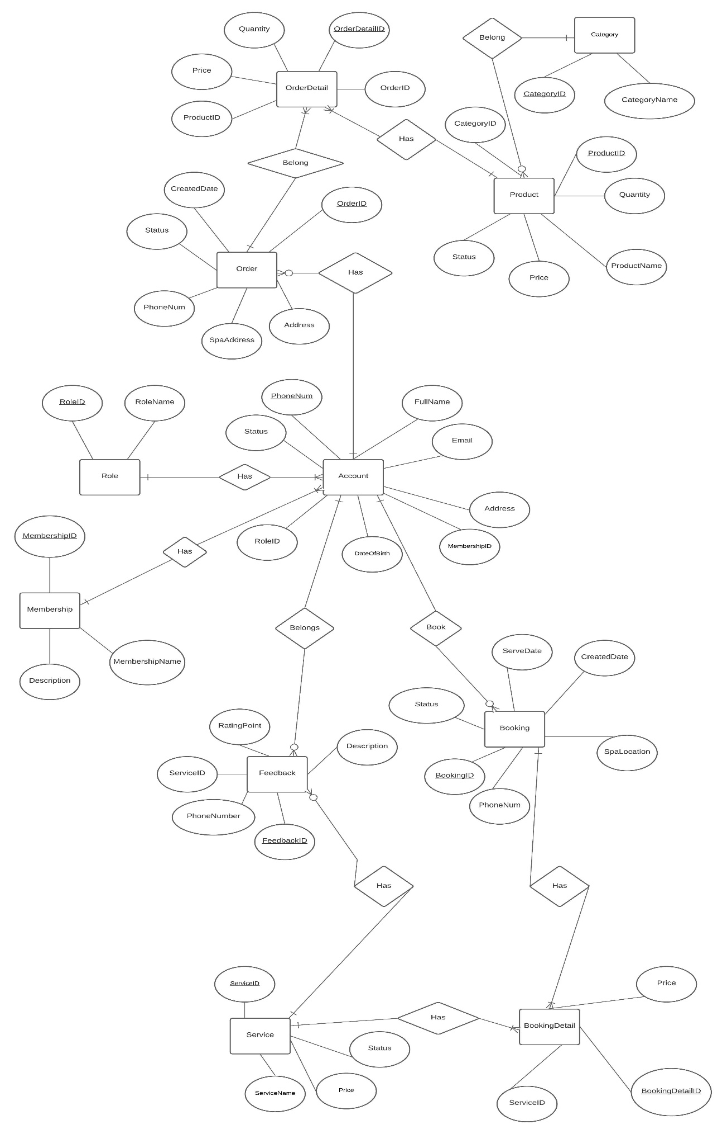

4.2 Data Dictionary

|  |  |  |  |  |
| --- | --- | --- | --- | --- |
| Data Element | Description | Composition or Data Type | Length | Values |
| ServiceID | ID of service of a spa salon which can be booked by customer | String | 5 | A string of numbers |
| Service Name | Name of a service of a spa salon | String | 50 |  |
| Price (Service) | The price of a service | Integer | 10 | A positive integer in VND |
| Status | Status of a service | String | 20 | Available / Unavailable |
| BookingDetailID | ID of a booking detail created by a customer who books a service/services of the spa salon | String | 5 | A string of numbers |
| Price (Booking Detail) | The price of a service that is in a booking detail (for storing data purpose) | Integer | 10 | A positive integer in VND |
| phoneNum | The phone number of a customer, customer can use this phone number to access to the SSMS | String | 11 | A string of numbers that can be 10 to 11 characters |
| fullName | Full Name of a customer | Alphabetic | 50 |  |
| Email | Email of a customer. Customer can use this email to receive promotion notifications | String | 100 | A string with an extension of an email (@gmail.com, @fpt.edu.vn, …) |
| Address (Account) | Address of a customer, can be the address to ship product | String | 200 |  |
| dateOfBirth | Date of birth of a customer | Date, MM/DD/YYYY | 10 |  |
| BookingID | ID of a booking created by a customer who books a service/services of the spa salon | String | 5 | A string of numbers |
| SpaLocation | Address of spa salon, can be the address to do the service | String | 200 |  |
| ServeDate | The datetime that customer arrives to the salon to get services done | Datetime, MM/DD/YYYY hh:mm | 16 |  |
| CreatedDate (Service) | Date generated when customer creates the booking | Date, MM/DD/YYYY | 10 |  |
| Status (Booking) | The status of the booking created | String | 20 | Waiting/ Cancelled/ Pending/ Done |
| MembershipID | ID of a membership that a customer has | String | 5 | A string of numbers |
| MembershipName | Name of a membership that a customer has | String | 20 | Bronze/ Silver/ Gold/ Platinum |
| Description (Membership) | Description of a membership of a customer | String | 200 |  |
| RoleID | ID of a role of a customer | String | 5 | A string of numbers |
| RoleName | Name of a role of a customer | String | 20 | Customer/ Admin/ Staff |
| FeedbackID | ID of a feedback from a customer to a service | String | 5 | A string of numbers |
| Rating Point | Point from customer rates for a service | Integer | 1 | A number from 1 to 5 |
| Description (Feedback) | The information from customer to rate the services | String | 200 |  |
| OrderID | The ID of an order that from customer to order products | String | 5 | A string of numbers |
| CreatedDate (Order) | Date generated when customer creates the order | Date, MM/DD/YYYY | 10 |  |
| Address (Order) | Address of a customer, can be the address to ship product | String | 200 |  |
| SpaAddress | Address of a salon that supplied products | String | 200 |  |
| Status (Order) | Status of an order | String | 20 | Waiting /Pending /Cancelled/ Done |
| Price (Order Detail) | The price of a product that is in an order detail (for storing data purpose) | Integer | 10 | A positive integer in VND |
| Quantity (Order Detail) | The quantity of a product that is in the order detail | Integer | 3 | A positive integer |
| ProductID | The ID of a product | String | 5 | A numeric string |
| ProductName | The name of a product | String | 50 |  |
| Quantity (Product) | The quantity of a product in storage | Integer | 7 | A positive integer |
| Price (Product) | The price of a product | Integer | 10 | A positive integer in VND |
| Status (Product) | The status of a product | String | 20 | Available / Unavailable |
| CategoryID | The ID of a product category | String | 5 | A numeric string |
| CategoryName | The name of a product category | String | 50 |  |

## 4.3 Reports

N/A

## 4.4 Data Acquisition, Integrity, Retention, and Disposal

DI-1: The SSMS shall retain Individual Customer orders for 12 months following the order’s delivery date and booking’s date.

# 5 External Interface Requirements

## 5.1 User Interfaces

UI-1: The system shall provide a help link from each displayed webpage to explain how to use that page.

## 5.2. Software Interfaces

No third-party interfaces are used

## 5.3. Hardware Interfaces

No hardware interfaces have been identified.

## 5.4. Communications Interfaces

CI-1: The SSMS shall send an email or text message (based on user account settings) to the Spa Customer to confirm acceptance of a schedule, order, and delivery instructions.

CI-2: The SSMS shall send an email or text message (based on user account settings) to the Spa Customer to report any problems with the schedule or order.

# 6. Quality Attributes

## 6.1. Usability

USE-1: 90% of new users shall be able to successfully order services or products without errors on their first try.

## 6.2. Performance

PER-1: The system shall accommodate a total of 200 users and a maximum of 70 concurrent users during the peak usage time window of 7:00 P.M. to 9:00 P.M. local time, with an estimated average session duration of 8 minutes.

PER-2: 95% of webpages generated by the SSMS shall download completely within 3 seconds from the time the user requests the page over a 20Mbps or faster Internet connection.

PER-3: The system shall display confirmation messages to users within an average of 2 seconds and a maximum of 5 seconds after the user sends information to the system.

## 6.3. Security

SEC-1: The system shall allow Customers to view only orders and schedules that they placed.

## 6.4. Safety

N/A

# 7. Internationalization and Localization Requirements

N/A

# 8. Other Requirements

Appendix A: Analysis Models

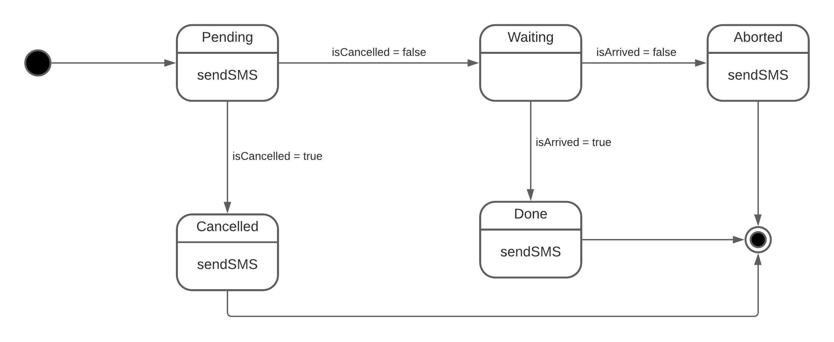State-chart of a booking created by customer

Activity Diagram of booking process  
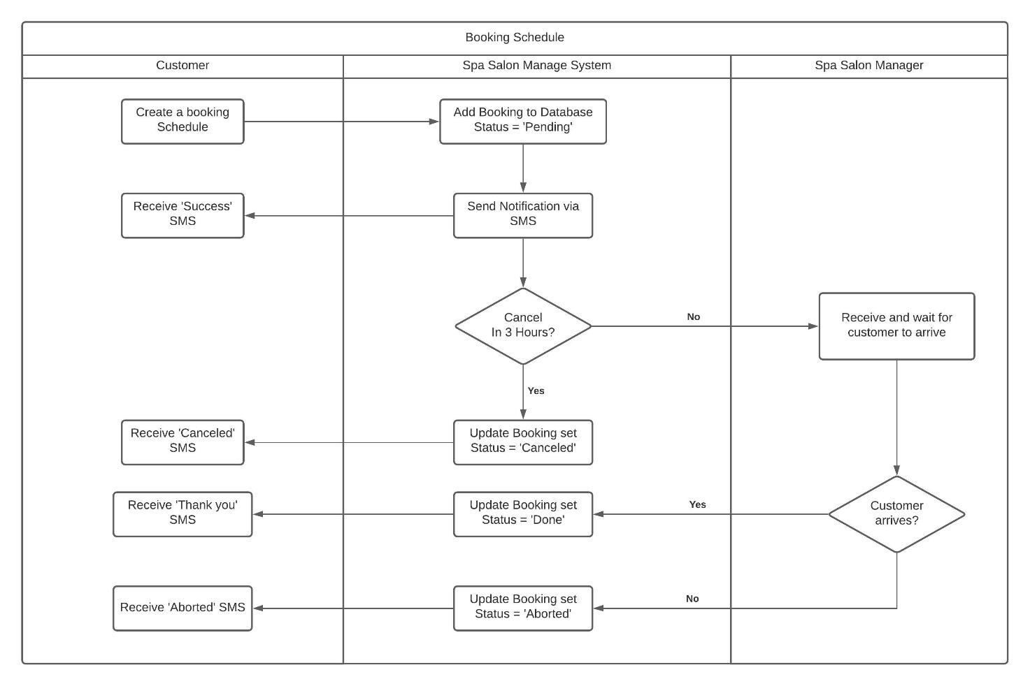

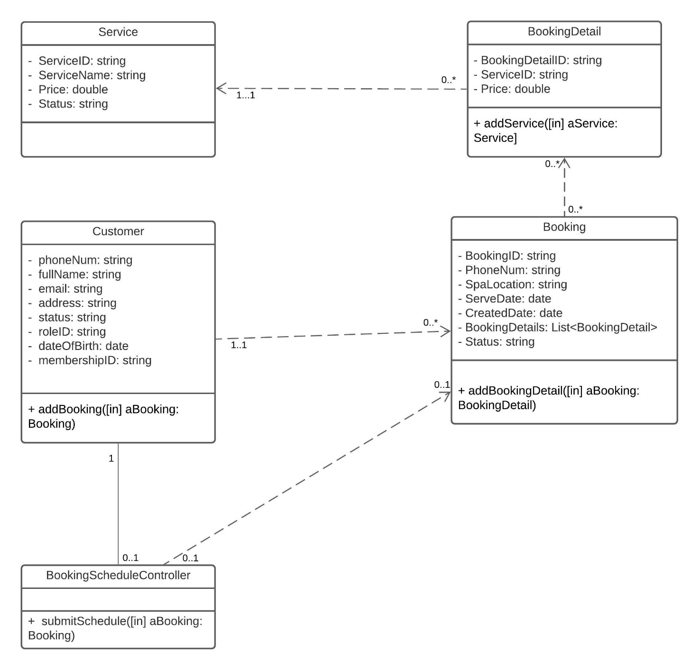Class Diagram for Booking Service 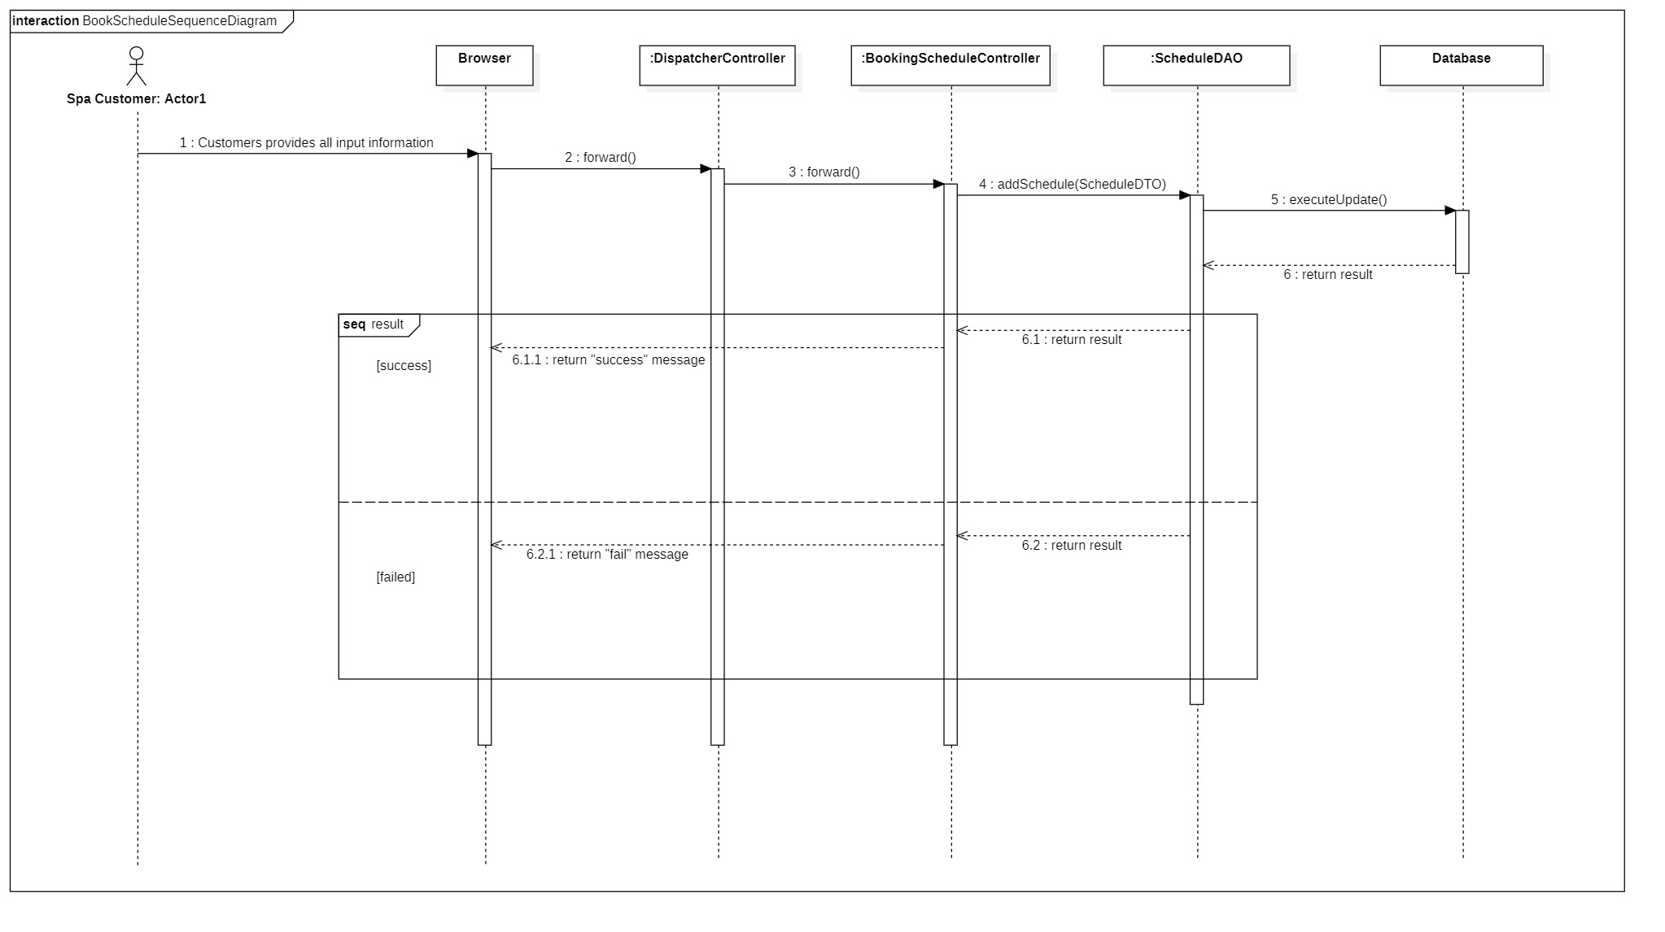Sequence Diagram for Booking Service